**Royal Caribbean International**

**Revenue Management Strategy and Analytics - Data Analyst Case Study**

**PART 1: WTD Expectations Presentation**

For this part, you will be provided with information about the business. Please answer the questions and prepare a presentation that addresses each one. Feel free to use any tools or programs to complete this task.

Introduction To Track:

**Track** is a measurement of how we expect business to develop, enabling us to meet our forecasts. Specifically, it reflects the weekly passenger bookings (pax) required from the deployment date of a sailing up to the sailing date. This helps ensure we achieve our forecasted revenues. The business uses Track to make data-driven decisions and evaluate performance.

Below is a hypothetical example of a **Track curve** for a single sailing, represented as a line graph:

* **X-axis:** Calendar weeks, starting from the deployment date up to the sailing date.
* **Y-axis:** The number of pax needed each week to meet the forecast.

**Example:**  
To meet the forecast for the week of June 24, 2024, we need to book **657 pax** by that time.

Calendar Week

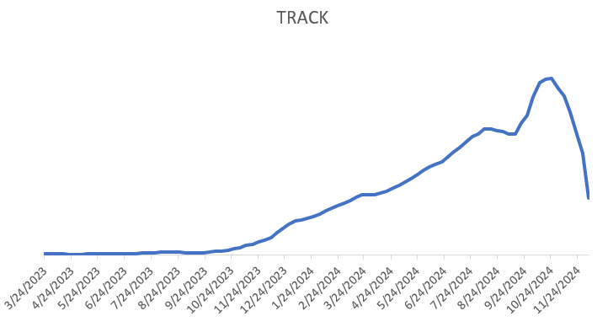

Pax Ask

657

WTD (Week To Date) Expectations:

Now that you are familiar with weekly targets, we will take this a step further. To make informed daily pricing decisions, it is essential to understand how many of the expected pax should be booked each day within a given week. These daily targets are known as **WTD (Week-To-Date) expectations**.

1. Using historical data, come up with what you think the WTD expectations should be at **sail_year, sail_month, product level**.
   1. A white grid with black text

      AI-generated content may be incorrect.Your results should look like the table below.
   2. Please explain your reasoning for each step of the task. Were there any abnormalities in the data? How did you handle the abnormalities?
   3. Feel free to walk us through your EDA to help us better understand how you got your results.
2. What are the implications of overestimating and under estimating WTD expectations and what does that mean in terms of revenue management?
3. Present summary statistics and explain any reason why some products sell/book more on other days with respect to other products.

**PART 2: SQL Questions**

You will be given a series of SQL questions based on the data in a star schema. Please have your code at the end of your presentation.